Install Gnome GUI on CentOS 7 / RHEL 7

# yum group list

**Output:**

Loaded plugins: fastestmirror

There is no installed groups file.

Maybe run: yum groups mark convert (see man yum)

Loading mirror speeds from cached hostfile

Available Environment Groups:

Minimal Install

Compute Node

Infrastructure Server

File and Print Server

Basic Web Server

Virtualization Host

**Server with GUI**

GNOME Desktop

KDE Plasma Workspaces

Development and Creative Workstation

Available Groups:

Compatibility Libraries

Console Internet Tools

Development Tools

Graphical Administration Tools

Legacy UNIX Compatibility

Scientific Support

Security Tools

Smart Card Support

System Administration Tools

System Management

**Step 1:** Install Gnome GUI packages using the [**YUM command**](https://www.itzgeek.com/how-tos/linux/centos-how-tos/linux-basics-30-yum-command-examples-for-linux-package-manager.html).

**CentOS 7:**

# yum groupinstall "GNOME Desktop" "Graphical Administration Tools"

**RHEL 7:**

# yum groupinstall "Server with GUI"

**Step 2:** Enable GUI on system startup. In [**CentOS 7 / RHEL 7**](https://www.itzgeek.com/tag/centos-7),  systemd uses “**targets**” instead of runlevel. The **/etc/inittab** file is no more used to change run levels. So, issue the following command to enable the GUI on system start.

To Create Soft Link of renlevel5.target file

# ln -sf /lib/systemd/system/runlevel5.target /etc/systemd/system/default.target

**Step 3:** Reboot the machine to start the server in the graphical mode.

# reboot

**License Agreement:**

Accept the license by clicking on the “**LICENSE INFORMATION**“.

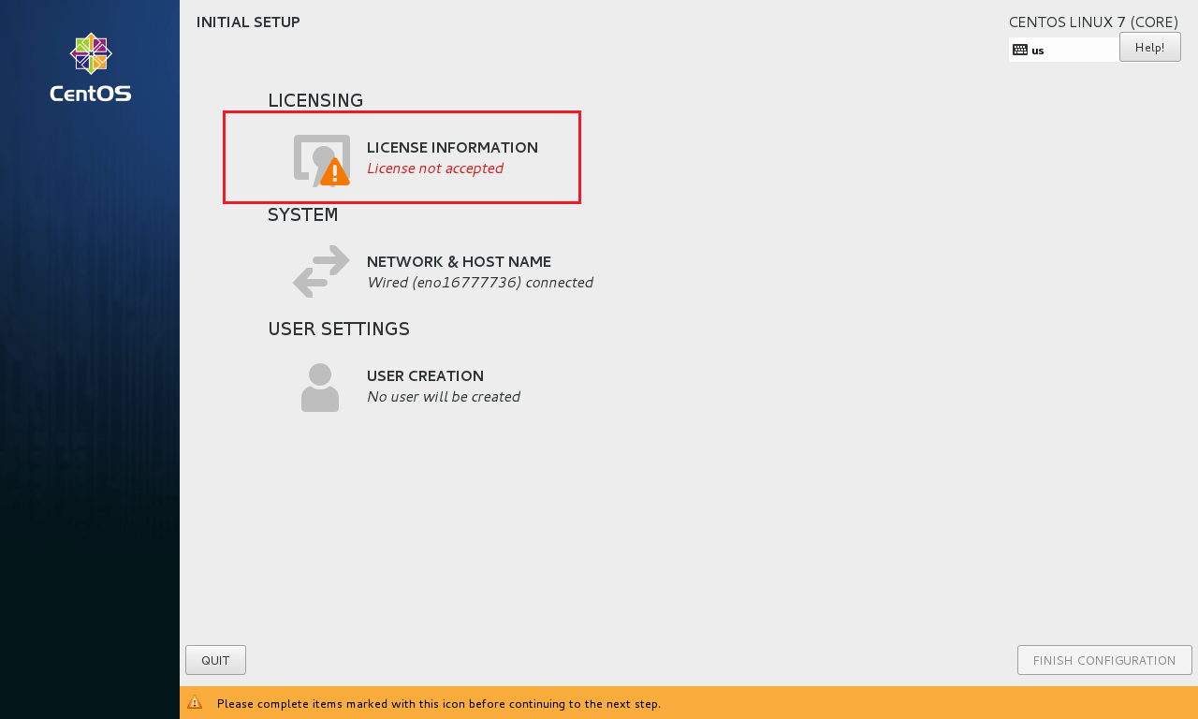

Install Gnome GUI on CentOS 7 – Licensing Page

Tick mark the “**I**accept**the license agreement**” and click on “**Done**“.

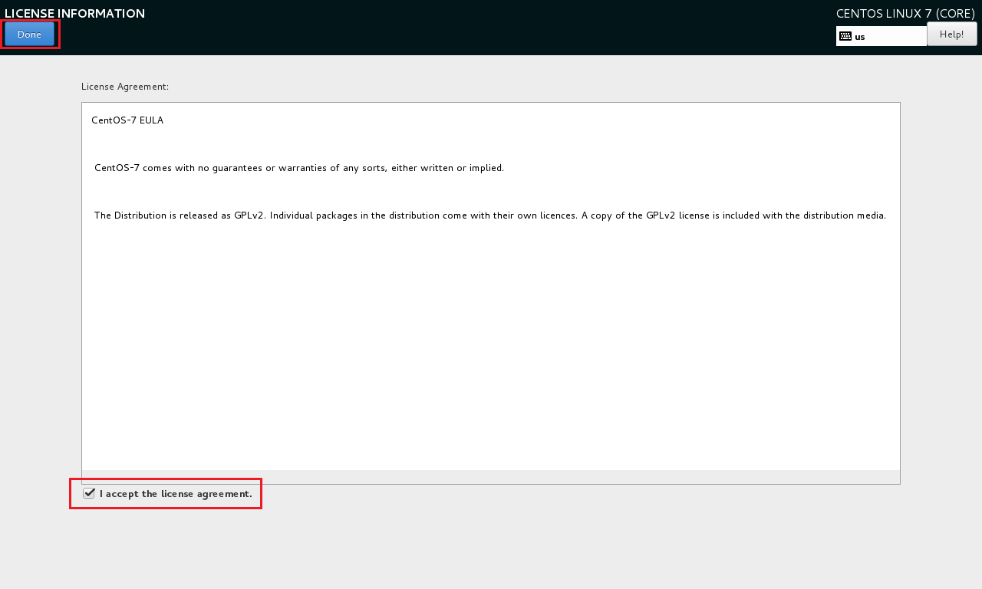

Click on “**FINISH CONFIGURATION**” to complete the setup.

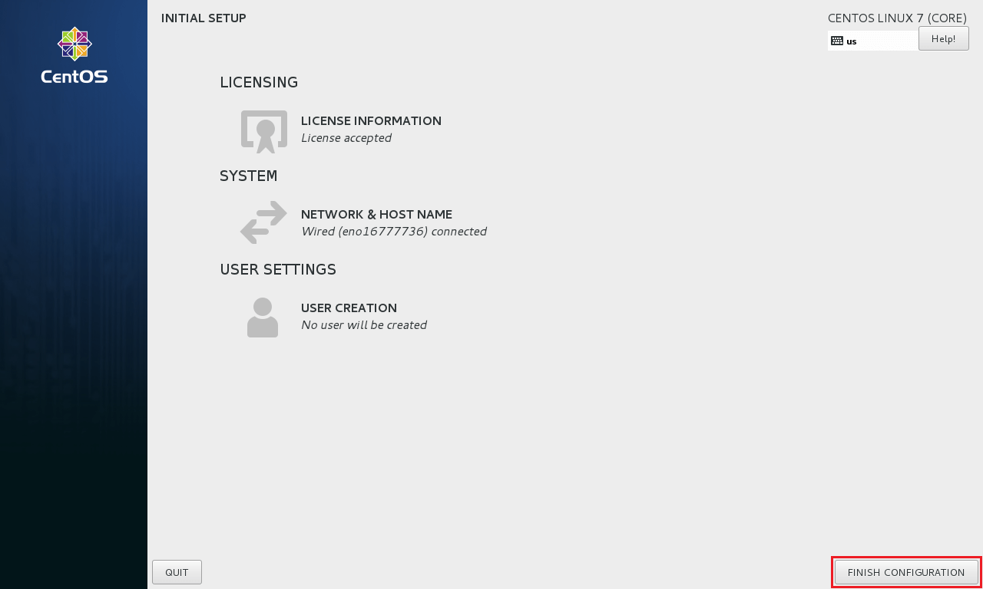

You may need to do some post configuration tasks, like **creating first user (local account), language, etc**.

Then finally you will get the desktop.

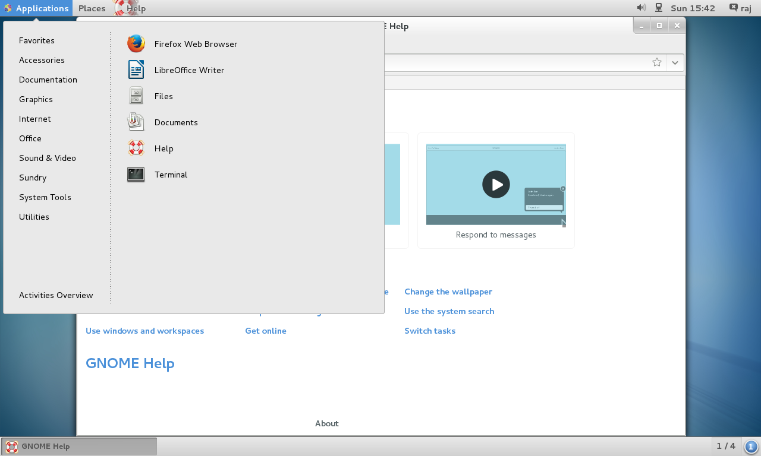

That’s All. You have successfully installed GUI on [**CentOS 7 / RHEL 7**](https://www.itzgeek.com/tag/centos-7).